Design Planning Techniques (Low – High Fidelity)

Your research, options investigated, comparisons and context that make these relevant, how they will be applied.

As a fourth stage of design thinking process – prototype is one of the most important stages, especially for an user or customer. Because at this stage customer will receive some idea or rough model of what it’s going to look like, at this stage customer can add some requirements and specifications.

A **prototype** is a draft version of a future product that can help to explore any ideas and describe a particular feature or the overall design concept to users. It is important to do this stage before any proper design developing started. There are two types of prototypes **high-fidelity** (fully functioning site/template with some functionality) and **low-fidelity** (usually paper drawings). <https://www.visual-paradigm.com/guide/ux-design/wireframe-vs-storyboard-vs-wireflow-vs-mockup-vs-prototyping/>

**Examples of low-fidelity prototypes:**

**Sketching**

Sketching is a low fidelity prototype method that can help to visualize at the very beginning of developing process. Can be done by pencil and paper. Wireframe and storyboarding are based on sketching.

**Storyboarding**

# What is Storyboard?

A storyboard is a visual representation of the scenes, dialogs, action in a sequential specific order. It is a method used to imitate ideas, designs and concepts for websites usually by presenting a sequence of wireframes in a order which could be already developed in the earlier development stage. <https://www.visual-paradigm.com/guide/ux-design/wireframe-vs-storyboard-vs-wireflow-vs-mockup-vs-prototyping/>

# Storyboard for game

At the very beginning of storyboard is creating "cards" that would describe plot points and events. Each card might be a few lines of text, script, a scribbled-down idea, or a sketch of a scene or even just a picture.

To accomplish the best result in creating a storyboard card some tactics might be handy.

First tactic is to create cards that would describe plot and idea. For example:

* **Primary Event Cards**
* **Secondary Event Cards**
* **Gameplay Event Cards**
* **Bonus Cards**
* **Character, attributes (sword for example)**
* Bosses or battle stage

Second tactic is to organize the board. Once all the story cards are created, it's time to put them into order. It is very important to start from somewhere, even if order is wrong, it is very easy to fix it by just shifting the around until desired result is achieved. It can be dome in **Chronological Order or State or Sequence Order.**

Third tactic or step is **review** and **revise.** After some “ playing” with a cards, putting them in different order it is important to step back and review what is accomplished so far. Some feedback on what have been accomplished is required.

<https://gamescrye.com/blog/how-to-storyboard-your-game/>

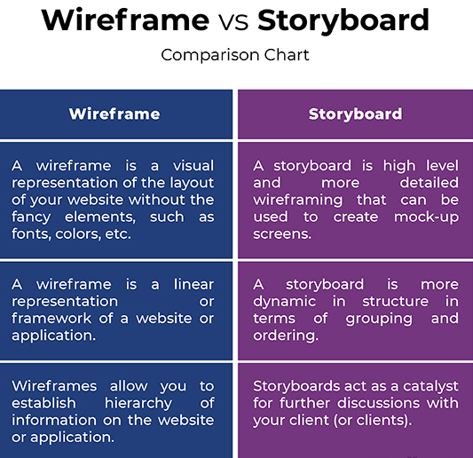

Summary

Wireframes and storyboards are verry similar, they basically follow the same pattern of navigation scheme and layout with no visual elements, thereby make life of web designers and web developers easier. Both wireframing and storyboarding are proposed techniques that are applied at very early stages as prerequisites in the web development process. However, storyboarding can be called - high level wireframing with better representation, sketches, layouts to share with the client to make sure that everybody is on the same page and work toward a goal. Wireframe and storyboard are playing one of the most crucial parts in UX deliverables of web development lifecycle.  
<http://www.differencebetween.net/technology/difference-between-wireframe-and-storyboard/#:~:text=A%20storyboard%20is%20quite%20similar,goes%20further%20inside%20the%20application>.

# Wireframe

**What is Wirefame?**

A wireframe is a sketch design of the future system, which must be fulfilled before any design work is started. Through clearness and simplicity, it allows anyone to read and understand it easily. Wireframe shows information with not many details, but enough to see a full picture and visualize a future product. At this method scenario can be showed to a customer for a future specialization and list of requirements from a customer. Wireframe can be called a blueprint, as it define structure, content and functionality.

Benefits of wireframing are**:**

* Wireframes are easy to draw. Can be completed by pencil and paper
* Usually, it is easy to understand wireframes
* Easy to modify.
* No coding needed.
* In-line annotations. Specification and annotations can be showed on sketches.

<https://www.visual-paradigm.com/guide/ux-design/wireframe-vs-storyboard-vs-wireflow-vs-mockup-vs-prototyping/>

**High fidelity**

**What is Mockup?**

A mockup is high-fidelity static design for representing a product. While a wireframe mostly represents a screen or webpage structure, a mockup shows how the actual screen is going to look like. A mockup helps you make final decisions regarding a screen’s color schemes, or the layout of visual GUI elements, but it is not interactive and not clickable.

While wireframes are design placeholders, mockups are built to give the viewer a more realistic impression of how the end product will look. While the wireframe is visually stunted, the mockup is close to the final version in appearance. In this way the mockup acts as the bridge between the wireframe and the prototype.

Although it lacks the functionality of a prototype, it can still provide the project sponsor with a picture of how a finished product can be, and help team members review their project visually. Thus, you can ask your potential users for feedback and make the necessary changes right away.

What is Prototyping?

A prototype is a draft version of a product that allows you to explore your ideas and show the intention behind a feature or the overall design concept to users before investing time and money into development. A prototype can be anything from paper drawings (low-fidelity) to something that allows click-through of a few pieces of content to a fully functioning site (high-fidelity).

A prototypes are computer-based, and usually allow realistic (mouse-keyboard) user interactions. High-fidelity prototypes take you as close as possible to a true representation of the user interface. High-fidelity prototypes are assumed to be much more effective in collecting true human performance data (e.g., time to complete a task), and in demonstrating actual products to clients, management, and others. Here are the benefits of a high-fidelity prototypes:

It is much cheaper to change a product early in the development process than to make change after you develop the site. Therefore, you should consider building prototypes early in the process.

Prototyping allow you to gather feedback from users while you are still planning and designing your Web site or targeted system.

<https://www.visual-paradigm.com/guide/ux-design/wireframe-vs-storyboard-vs-wireflow-vs-mockup-vs-prototyping/>

Difference between Wireframe and Storyboard

Meaning

 – Wireframes and storyboards are two of the most frequently produced UX deliverables, which are often confused with each other. A [wireframe](http://www.differencebetween.net/technology/difference-between-wireframe-and-storyboard/) is a basic pictorial representation of your website or app that shows how each one of the pages interconnects. It is more like a laundry list of what goes into each page from the media and content perspective. A storyboard is very similar to a [wireframe](http://www.differencebetween.net/technology/difference-between-sitemap-and-wireframe/) except it is advanced wireframing created during the initial research process on whiteboards. Both are equally important and play their respective roles in the overall web development lifecycle.

Structure

 – A wireframe is a linear representation of a website or web page structure, kind of a mock up screen of what the actual thing will look like. It takes a more linear approach to planning the whole layout of the website, like a skeletal representation or [framework](http://www.differencebetween.net/technology/difference-between-methodology-and-framework/) of what goes into each page. A storyboard is quite similar to wireframes wherein they both map out all the components of the website. However, a storyboard is a more detailed representation, a high level outline including descriptions of what happens as user goes further inside the application. Storyboards are more [dynamic](http://www.differencebetween.net/technology/difference-between-dynamic-and-static-hashing/) in structure in terms of grouping and ordering.

Purpose

 – The most important reason why you should always wireframe is that wireframing allows you to determine clear goals and establish hierarchy of information on the website or webpage. This means it lets you map out where the important elements of the website are going into, like a call to action, such as a sign-up form, a feedback page, or any important information. It also simplifies communication between you and your client. A storyboard basically serves the same purpose but in a more detailed fashion. It acts as a catalyst for further discussion with your client (or clients).

<http://www.differencebetween.net/technology/difference-between-wireframe-and-storyboard/#:~:text=A%20storyboard%20is%20quite%20similar,goes%20further%20inside%20the%20application>.

Designing a game is a complex and time-consuming process containing several stages that often take months to complete. Whether a game is a simple one or one with rich graphical elements and physics engines to show realistic actions and movements, it all begins with a game wireframe. A **game wireframe** is nothing more than a basic blueprint design that shows game assets, characters, [interactions](https://mockitt.wondershare.com/ui-ux-design/interaction-design.html), and other elements in a sort of high-level overview. Therefore, an application for a mobile game wireframe or video game wireframe must have a selection of assets and effects that can mimic the actual functions of the game and the various states of a particular action taken by the user. In its simplest form, a game wireframe shows you how a particular scene will work, how the user can interact with the elements, and how the scene with change along with these interactions. <https://mockitt.wondershare.com/wireframe/game-wireframe.html#:~:text=A%20game%20wireframe%20is%20nothing,sort%20of%20high%2Dlevel%20overview>.

## An introduction to wireframing

### 1. What is a wireframe?

Wireframing is a practice used by [**UX designers**](https://careerfoundry.com/en/courses/become-a-ux-designer/) which allows them to define and plan the information hierarchy of their design for a website, app, or product. This process focuses on how the designer or client wants the user to process information on a site, based on the [**user research**](https://careerfoundry.com/en/blog/ux-design/how-to-conduct-user-experience-research-like-a-professional/) already performed by the UX design team.

When designing for the screen you need to know where all the information is going to go in plain black and white diagrams before building anything with code—[**whether that’s a developer coding it, or you the designer**](https://careerfoundry.com/en/blog/ux-design/why-should-designers-learn-to-code/). Wireframing is also a great way of getting to know how a user interacts with your interface, through the positioning of buttons and menus on the diagrams.

Without the distractions of colors, typeface choices or text, wireframing lets you plan the layout and interaction of your interface. A commonly-used argument for wireframing is that if a user doesn’t know where to go on a plain hand-drawn diagram of your site page, then it is irrelevant what colors or fancy text eventually get used. A button or call to action needs to be clear to the user even it’s not brightly colored and flashing.

### 3. Things to consider before you start wireframing

As we mentioned above, different UX designers approach the task of wireframing in different ways. Some like to draw by hand, while others like to use apps or tools found online. But more often than not, the decision to use online tools or to wireframe by hand, and the process used to get to from wireframe to code, is less related to the individual preference of the UX Designer, and much more related to what approach the particular situation requires. It depends largely on how much emphasis there is on visual design in a project, and how much uncertainty there is with respect to what is being designed.

Here are a number of ways different designers can structure the process from design to implementation:

* Wireframe > Interactive Prototype > Visual > Design
* Sketch > Code
* Sketch > Wireframe > Hi-Def Wireframe > Visual > Code
* Sketch > Wireframe > Visual > Code

If the task is very narrow and the visual design is either set or considered unimportant (such as with many backend administrative interfaces), then going from a sketch to coding/development makes sense, whereas if the time and resources and the business value are all high, then spending the time to make a high-definition wireframe and going through a cycle of testing with a fully realized interactive prototype makes better sense.

### 4. The best tools for wireframing

There are heaps of [**free wireframe tools**](https://careerfoundry.com/en/blog/ux-design/free-wireframing-tools/) out there, so you should experiment with as many as you can to find the ones that suit you the best. Don’t forget that [**you can also just use pen and pape**](https://blog.prototypr.io/how-paper-wireframing-will-make-you-a-better-designer-5a57db8dca13)r! Below we’ve listed three online tools we find particularly good. The examples below all have free trials, so check them out!

[**UXPin**](https://www.uxpin.com/)**:** UXPin has a wide range of functionalities, but one of the best ones is how it facilitates building responsive, clickable prototypes directly in your browser.

[**InVision**](http://www.invisionapp.com/)**:** InVision allows you to get feedback straight from your team and users through clickable mock-ups of your site design. It’s completely free too!

[**Wireframe.cc**](https://wireframe.cc/)**:** Wireframe.cc provides you with the technology to create wireframes really quickly within your browser, the online version of pen and paper.

## 6 Steps to make a wireframe

### 1. Do your research

Remember: [**UX design is a process**](https://careerfoundry.com/en/blog/ux-design/the-ux-design-process-an-actionable-guide-to-your-first-job-in-ux/), and wireframing isn’t the first step in this process. Before you even think about picking up a pen and paper, you need to have covered the first two steps; namely understanding who your audience is by way of user research, detailing requirements, [**creating user personas**](https://careerfoundry.com/en/blog/ux-design/how-to-define-a-user-persona/) and defining use cases, and complementing this with further competitor and industry research. What does that mean? That means carrying out analysis of similar product lines to your own, digging into [**prevailing UX trends**](https://www.invisionapp.com/inside-design/ux-trends-for-2019/) and [**best practises**](https://careerfoundry.com/en/blog/ux-design/ux-best-practices/), and, of course, reviewing your own internal design guidelines.

And if you’re designing a new feature, don’t be afraid to research outside of your domain. Introducing tracking and data visualization as part of your logistics company’s service? Perhaps it’s worth checking out some fitness or nutrition apps on **[Dribbble](https://dribbble.com/)** or **[Behance](https://www.behance.net/)** for some ideas. Creativity is often set loose at point where fields of expertise intersect, after all.

[**Unsure what user research is and why it’s very, very important? Let us explain.**](https://careerfoundry.com/en/blog/ux-design/how-to-conduct-user-experience-research-like-a-professional/)

#### Curious about a career in UX design?

Start learning for free!

**[](https://careerfoundry.com/en/short-courses/become-a-ux-designer/?popup-tracking=blog-inline-UXD)**

### 2. Prepare your research for quick reference

You can imagine how much quantitative and qualitative data those various phases will produce. Well, that’s what you need to keep in mind while drawing out your wireframes. If you’re a mere mortal, you might struggle to both retain and recall all of that, so I recommend scribbling a cheatsheet with your business and user goals (your requirements), your [**personas**](https://careerfoundry.com/en/blog/ux-design/what-is-a-persona/), use cases, and perhaps some reminders of the coolest features you stumbled across in your competitor research. A few choice quotes from your audience might also help focus your attention on the user’s experience, which is—never forget—what you’re designing!

### 3. Make sure you have your user flow mapped out

Your wireframing is going to get very messy very quickly if you don’t have an idea of how many screens you’ll need to produce and the flow you expect the user to follow. It’s important to have a watertight concept of where your users will be coming from (which marketing channel, for example, and off the back of what messaging), and where you need them to end up. If you’re already well-acquainted with UX vocabulary, your internal voice will be alternately screaming “[**user flows**](https://careerfoundry.com/en/blog/ux-design/user-flows-vs-wireframes/)” and “information architecture”.

Good information architecture will ensure that your users are self-sufficient (fewer messages to your customer service asking how to do something painfully simple), lower levels of user frustration (and ultimately more satisfaction and trust), and therefore lower drop-off or drop-out rates. Which probably means more revenue, and probably means happy managers—and a job well done.

[**Don’t know what Information Architecture is? We’ve got that covered for you too.**](https://careerfoundry.com/en/blog/ux-design/a-beginners-guide-to-information-architecture/)

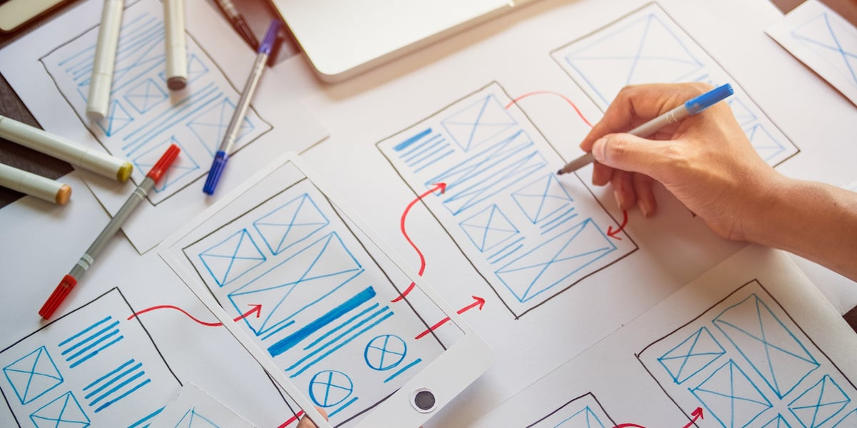

### 4. Draft, don’t draw. Sketch, don’t illustrate

Ok, now we’re on step four and you can finally start putting pen to paper. Sorry it’s taken this long, but the previous steps were critical: The old adage that you should look before you leap is 100% relevant to UX.

Anyway, let’s get some wires on your frame. Remember: you’re outlining and representing features and formats, not illustrating in mighty fine detail. There’s nothing worse than a blank piece of paper, so you need to start getting your ideas down pronto—that’s the imperative for step three. Don’t think about aesthetics, don’t think about colors—the UI designer can deal with that. And if you’re the only designer at your fledgling startup… well, just do it later.

A good, thick marker pen (a Sharpie, as our friends in the US call them) is a handy tool for this stage of wireframing. Why? Because it prevents you from drowning yourself in detail. You’ll focus on delineating the functional blocks that form the skeleton of your design. As Jeff suggests in the video above, pose yourself the following three questions while you’re sketching:

* How can you organise the content to support your users’ goals?
* Which information should be most prominent? Where should your main message go? What should the user see first when arriving at the page?
* What will the user expect to see on certain areas of the page?
* Which buttons or touch points does the user need to complete the desired actions?

Once you have a few variations of your first screens, you might want to do a bit of collaborative wireframing with a fellow designer or product manager. What’s that mean? Simple. Lift your wireframes off the paper and onto a whiteboard, and play around with them. Ask yourself and one another; “Are we creating something usable that meets our audience’s needs?”

### 5. Add some detail and get testing

So you have a flow and you have your screens, and you’ve corroborated your ideas with some clued-up colleagues. The next step is to add some informational details to prepare your wireframe for its upgrade, Megatron-style, to prototype-mode.

Add detail in the way you would naturally process a screen, or the page of a book: from top-to-bottom and left-to-right. Remember: Your wireframe is the skeleton of your site. You’re not adding the muscle just yet—the content and the copy. To extend the metaphor somewhat uncomfortably, these elements are the ligaments and tendons that will connect form and functionality. Think about the following:

* [**Usability**](https://careerfoundry.com/en/blog/ux-design/what-is-usability/) conventions, such as putting the navigation at the top next to your logo, having a search box on the top right, and so on
* Simple, instructional wording for i.e. calls-to-action
* Trust-building elements: What do you need to build trust in your customers and where would be the best place to put these elements?
* Tooltips to indicate any functionality that could be included in a prototype transition

Once you’ve done all that, you’re ready for your first user tests. At this stage, your users may well be your colleagues. Indeed, one of the joys of the humble wireframe is that it [**serves as a common language between designers, stakeholders and web and app developers**](https://www.invisionapp.com/inside-design/how-to-wireframe/). You can use tools like **[UsabilityHub to preference test screens](https://usabilityhub.com/)** and collect qualitative feedback, and **[Prott to test and check understanding of the basic user flow](https://prottapp.com/features/)**. With this tool, you can simply photograph and upload your hand-sketched wireframes, and then connect them to user button overlays. Clever stuff!

[**Know nothing about Usability Testing? Here’s a guide for beginners.**](https://careerfoundry.com/en/blog/ux-design/how-to-conduct-usability-testing-a-step-by-step-guide/)

### 6. Start turning your wireframes into prototypes

Once you’ve documented and acted upon the feedback from your first prototype, you can start developing your high-fidelity prototypes. There are lots of [**slick tools out there for this, from Proto.io to Adobe XD and Framer**](https://www.creativebloq.com/web-design/top-10-prototyping-tools-2016-21619216), but the most well-known are [**Sketch and the browser-based, new(ish) kid-on-the-block, Figma**](https://careerfoundry.com/en/blog/ui-design/figma-vs-sketch-the-new-ui-design-tool-that-everyones-talking-about/). Once you’ve developed your wireframes in Sketch, you can import them into the industry-leading prototyping tool InVision (which, incidentally, we built a course in conjunction with) and interlink your screens for a second round of high-fidelity user testing. It’s at this point that we’ve most certainly crossed [**from wireframing to prototyping**](https://www.invisionapp.com/inside-design/wireframe-prototype-difference/). To find out more about that, you’ll have to read another article.

Let’s summarize by reviewing three key principles to keep in mind when you’re producing your wireframe.



## How to make your wireframe good: Three key principles

The following points should be at the forefront of your mind when building your wireframe:

### 1. Clarity

Your wireframe needs to answer the questions of what that site page is, what the user can do there, and if it satisfies their needs. Your wireframe is an aid for you to visualize the layout of your site page and ensure that the user’s most important questions are answered and goals are achievable without being distracted by more aesthetic considerations.

### 2. Confidence

Ease of navigation through your site and clear calls-to-action increase user confidence in your brand. If your site page is unpredictable, or has buttons or boxes in unexpected places user confidence diminishes. A lot of this information can already be organized at the wireframing stage. Using familiar navigational processes and placing buttons in commonly-used and intuitive positions, user confidence will soar–and that’s before you’ve even gotten around to thinking about colors and styles.

### 3. Simplicity is key

Too much information, copy, or links, can be distracting to the user and will have a detrimental affect on your users’ ability to achieve their goals. You want your users to be able to find their way through your site with as little extra ‘fluff’ as possible, to the elements that map to their most significant goals in a given context.

Your wireframe should be a visual guide to the framework of your site and how it will be navigated. Attractiveness at this stage is not a consideration. Once you’ve decided who your product or service is for, you can begin laying out the information they are looking for in an intuitive and natural way that is not only familiar to them as users of this kind of service, but that also guides them towards the conversion point or otherwise helps them to achieve their goals in the interaction. By presenting your information in this way, you are aligning both the business goals of your site with the needs of the customer.

<https://careerfoundry.com/en/blog/ux-design/how-to-create-your-first-wireframe/>

## When should you use wireframes?

The main purpose of wireframes is to share basic but key information about the product’s design. So the earlier you can integrate wireframes in the process the better. Wireframes should be quick, simple, and compatible with a lot of alterations.

Typically, you should consider creating wireframes in the discovery stage of the [**product cycle**](https://www.interaction-design.org/literature/topics/product-life-cycle#:~:text=The%20product%20life-cycle%20is,maturity%20and%20saturation%20and%20decline](%3Chttps://www.interaction-design.org/literature/topics/product-life-cycle#:~:text=The%20product%20life%2Dcycle%20is,maturity%20and%20saturation%20and%20decline.)%3E)). Designers use wireframes to work with stakeholders to identify business requirements, figure out the scope of the product and more.

## Wireframe fidelities

Wireframes aren’t all created equal. Even though they all serve the same purpose, wireframes vary based on the level of fidelity that you design them with. So let’s take a look at your different options.

### Low-fidelity

Typically, you should consider creating wireframes in the discovery stage of the product cycle. They communicate very basic page structure and don’t take into account details such as grid, scale or accuracy.

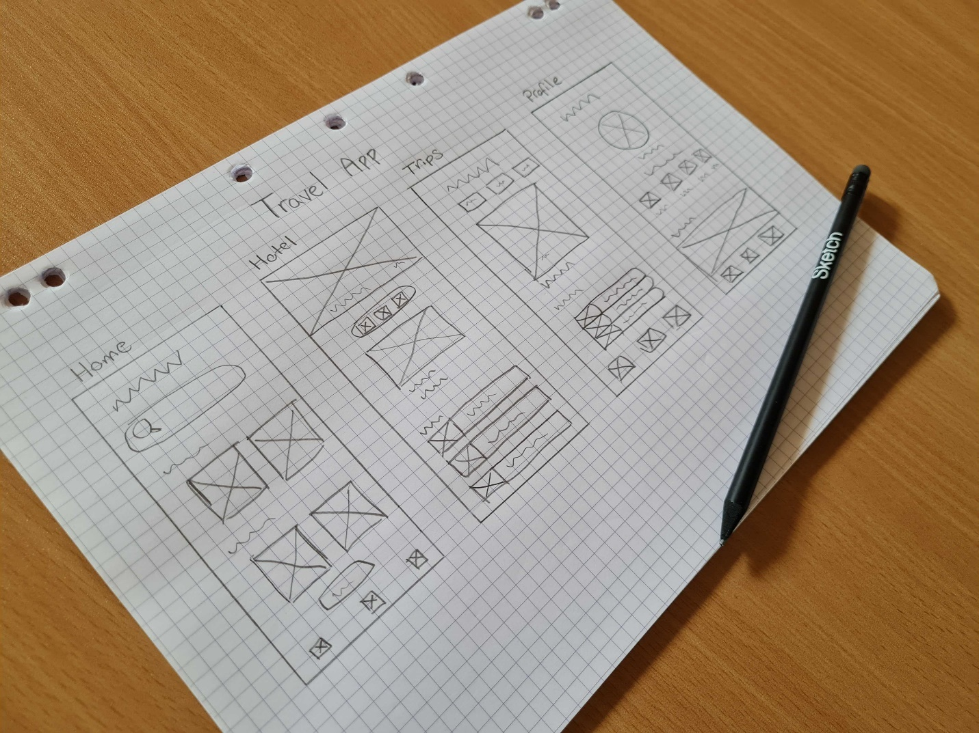

A low-fidelity wireframe of a Travel app idea. They’re quick sketches that you can create with pencil and paper.

You can design low-fidelity wireframes using pen and paper or sketching apps. They’re great for sharing on-the-spot ideas with basic shapes, images and content. They’re especially useful in stakeholder meetings to help everyone agree on a certain direction for what the product would look like. Plus, they’re also very handy for designers that want to have different options to show. And of course, because each one is basic, the design team can test ideas without wasting time creating pixel-perfect mockups.

### Medium-fidelity

The most popular option for wireframes is medium-fidelity. They add a more accurate structure and design layout than low-fidelity ones. Medium-fidelity wireframes still avoid detailed elements such as color, UX copy, images and typography. However, they do offer more distinct features and more detail in each component.

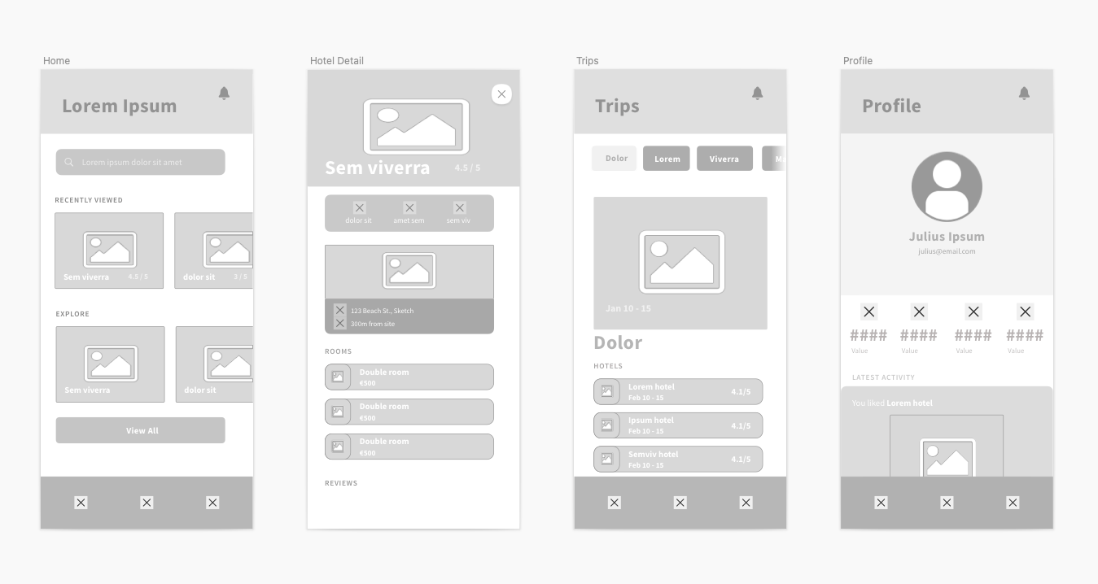

A medium-fidelity wireframe for the same Travel app. They show more details and you can design them in wireframing tools like [**Sketch**](https://www.sketch.com/).

Another key difference is that you design medium-fidelity wireframes using a digital wireframing tool like [**Sketch**](https://www.sketch.com/) — although you should still use them early in the product’s lifecycle to help shape the final result. By using a wireframing tool you can alter font weights and grey shades to give a little more detail to your design.

### High-fidelity

Finally, high-fidelity wireframes — also known as mockups or prototypes in some cases — take details to the next level. Instead of having placeholder text and images, they feature more detailed and relevant components.

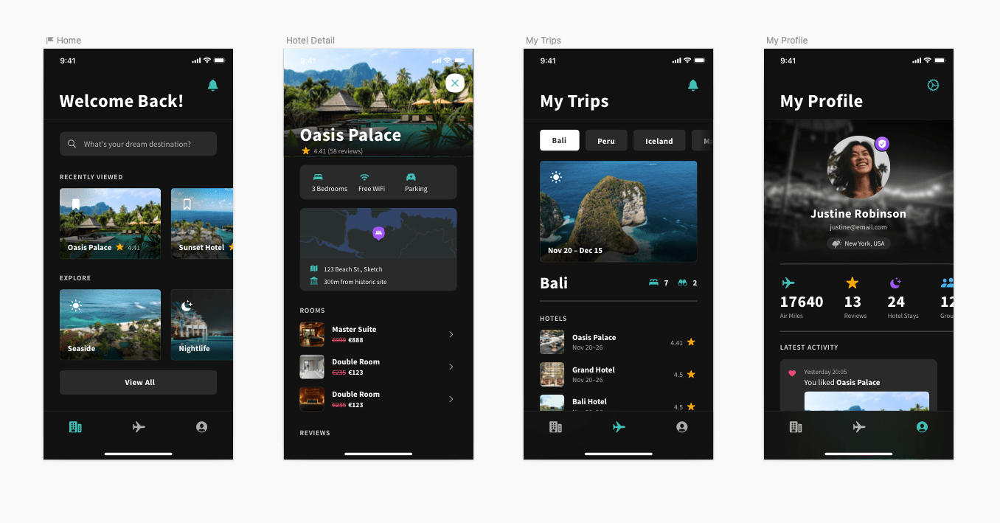

A high-fidelity wireframe of our Travel app idea. You’ll need a wireframing tool like [**Sketch**](https://www.sketch.com/) to create these, and they add a lot more detail to your concept.

Reserved for the later stages of a product’s design cycle, they help designers and stakeholders break down more complex ideas. If you’re designing a menu system, interactive map, or you want to go the extra mile and provide a more detailed mockup of your product, a high-fidelity wireframe is for you. And, just like with medium-fidelity, a digital design tool like Sketch can help you create one with ease.

Now you have an understanding of what wireframes are. They are important tools to use in your product design journey, and will make your design process even more efficient.

<https://www.sketch.com/blog/2022/01/27/what-is-a-wireframe/>

# How to Storyboard Your Game

posted on OCTOBER 17, 2017

No, storyboarding is not holding someone down and reading them your story until they beg you to stop, drowning them from your outpouring of words. Storyboarding is not another form of torture (or shouldn’t be!), but rather a powerful tool to use in game design. When you storyboard your game, your are creating a set of interchangeable cards that will make a simple representation of your scenes in logical order. It's a visual way of [designing your game's story](http://gamescrye.wpengine.com/blog/starting-your-game-with-a-story/) with a series of “cards” or other visual elements, to encapsulate characters, scenes, items, tone, actions, gameplay functionality and more—it can be a great tool to use in the design process of your game!

## Why Storyboard Your Game?

Storyboards can help give you a better visual overview, which is especially useful when building a game with a lot of steps or with a focus on a particular visual presentation. It's a very quick way of getting a perspective into what the game will look like prior to production or even before a game prototype is tested. When you storyboard your game lore and your various gameplay interactions, it can be an easy way to unravel problem areas before they arise at the expensive development stage.

**Paper Prototyping** is a technique that consists of creating hand drawings of user interfaces in order to enable them to be rapidly designed, simulated and tested. As simple as this technique may look like, it has been effectively used since the 1980s and is likely to continue to be used with a guaranteed degree of success for many more years to come. The objective of this article is to define[paper prototyping](https://www.interaction-design.org/literature/topics/paper-prototyping?ep=ug0)and explain how this technique can be used for[usability testing](https://www.interaction-design.org/literature/topics/usability-testing?ep=ug0). I opted to write the article mostly in bullet form so that it can act as a quick reference.

## The 2 major uses of paper prototypes

Paper prototypes are used:

* **To communicate ideas**: between designers, developers, users and other stakeholders in the first stages of the user-centered design process.
* **As a usability testing technique**: to observe the human interaction with user interfaces even before these interfaces are designed and developed.

## Usability testing using paper prototypes – The People

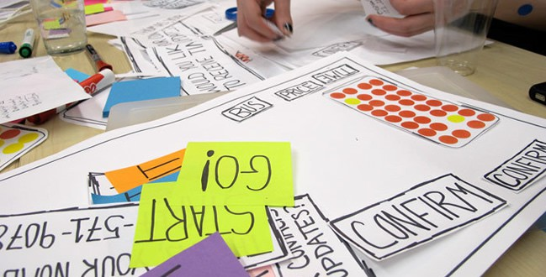Preparing for a usability testing session (Image credit: [DavidBellona](http://davidbellona.com/17858/380645/mfa-work/coursework-curriculum" \t "_blank))

Paper prototypes can be used to conduct usability testing of any type of user interface – be it a website, mobile application or software. To be able to do so, you need the following people:

* **Real Users**: As stated by Jakob Nielsen, 5 users should be able to identify about [85% of all usability problems](http://www.useit.com/alertbox/20000319.html). These users will interact with a paper version of the user interface that is being tested.
* **A Facilitator**: Usually a[usability](https://www.interaction-design.org/literature/topics/usability?ep=ug0) professional and his/her role is to record the issues raised during the meeting. Where necessary, the facilitator needs to probe into the issues raised so that these are well documented. Since the ideas of the people present may be conflicting at times, the facilitator needs to act as a mediator between the different parties.
* **A Human Computer**: This person (typically the lead developer or someone who knows how the system is supposed to work) manipulates the paper prototype so that it can provide the feedback based on the user’s interaction. The human computer will not explain or give hints to the users about [how the interface is supposed to behave](https://www.interaction-design.org/literature/topics/ui-design?ep=ug0) so that the users are left entirely on their own to perform the tasks that they have been assigned.
* **Observers**: These people are typically members of the development team. Their role to observe and interpret the users’ interactions with the paper prototype.

## Usability testing using paper prototypes – The Method

Since paper prototyping has been around for so many years, there exist quite a number of slight variations as to how usability testing using paper prototypes is conducted. In fact, I have included the videos below to show these slight variations.

Generally speaking, the different screens are sketched prior to the testing. Typical use cases are then created and the users are requested to try and perform them by interacting with the prototype. Based on where they press or select, the human computer will change or alter the prototype by introducing whole screens or snippets, depending on how the system is intended to react. As you will notice, sometimes the facilitator and the human computer is the same person, thus creating the wrong impression that the human computer is speaking during the usability testing session. It is very important that these sessions are well documented using a video camera in order to be able to assess user reactions after the test.

## The Advantages of Paper Prototyping

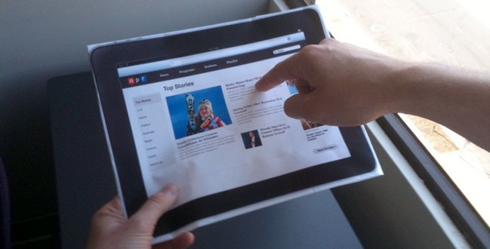Usability testing of an iPad application using paper prototyping (Image credit: [SND](http://www.snd.org/2010/04/inside-the-design-process-for-nprs-ipad-app/app-paper-prototype-2/))

* **User involvement at an early stage**: Enables the involvement of developers, designers, users and other stakeholders very early in the design process, even before any design or coding has been implemented. Since the interface is built up step by step, it usually meets the expectations of all team members
* **Cost-effective**: Paper prototyping is very cheap to to implement and test (much cheaper than engaging a designer [to create mock ups](https://www.interaction-design.org/literature/topics/mock-ups?ep=ug0)of the user interface or a developer to code a prototype). Additionally, paper is cheaper than the software that would need to be used to create simulations of design mock ups. Paper prototyping is also cost effective in the long run because of the fact that it identifies problems before any design or development has commenced
* **Encourages creativity**: and sharing of ideas across a multidisciplinary team that would otherwise have great difficulty in doing so
* **No design or coding skills needed**: The prototypes are not coded as they are simply hand drawn on paper – thus eliminating the need to be drawn by a graphic designer
* **Less resource consuming**: Creating and usability testing using paper prototypes require less human and financial resources than other prototyping and interface testing techniques
* **Rapid evaluation and testing**: User interfaces can be quickly prototyped and tested. Thus, they also facilitate the quick introduction of modifications and refinements needed to address any usability problems that have been identified
* **Assists in documentation**: Annotations can be written on sticky notes and stuck to the prototypes. These will assist designers and developers when they are creating the actual system
* **Endorsed by several usability professionals**: ans successfully applied for the past 30 years. Paper prototyping is likely to persist for may years to come since it is not technology bound

<https://usabilitygeek.com/paper-prototyping-as-a-usability-testing-technique/>

In the world of digital design, we have a lot of different tools that make the process of prototyping really simple. But still pen and paper remain the most useful tools for UX designers.

Paper prototyping can be extremely helpful during the early-stage conceptualizing — when a team needs to explore a variety of different concepts and choose the one that will be used. The paper prototype allows quickly visualize and test various ideas.

This article is a quick guide to paper prototyping & testing for digital interfaces.

# Advantages and Disadvantages of Paper Prototyping

Before discussing specific tips of paper prototyping, it’s worth saying a few words about advantages and disadvantages of this approach.

Let’s start with advantages:

* It’s fun. Paper prototyping ought to be fast and fun. If it’s slow and painful, there’s definitely something wrong with your prototyping process.
* Rapid iteration. It takes minutes to create a few different versions of a design.
* Low cost. Paper prototyping is very inexpensive. Basic toolset includes pen and paper. Digital prototyping tools vary in price. But most digital prototyping tools require either a one-time purchase or a subscription.
* Low commitment. No one wants to throw out a digital prototype that took hours to create. It’s much easier to throw out a sketch that takes only 5-minute to create.
* Early feedback from real users. Real users can be involved in product design before actual design and coding begins.
* Eliciting honest feedback. An important advantage of paper prototypes is their sketchy look. The prototypes don’t look like you’ve spent a lot of time on them. As a result, people feel more comfortable criticizing sketches rather than polished designs.
* Team building. Since paper prototyping doesn’t require any special skills, anyone can participate in this process. You can easily do paper prototyping as a group activity. People from all kinds of backgrounds can participate in creating paper prototypes.

Now, let’s talk about drawbacks:

* Hard to interpret design. Paper prototypes require a great deal of imagination from test participants—they have to imagine how the future state of a product will look like just by looking at the paper.
* Testing only in person. It’s hard to test a paper prototype when participants are widely dispersed geographically.
* Need to transfer papers to the digital format. The downside of a paper prototype is that you’ll need to convert it in a digital prototype anyway.

# When to do paper prototyping

Paper prototyping is excellent for:

* Brainstorming sessions (when a team needs to outline the steps in a user flow or explore/validate a variety of layouts)
* Proof of concept testing (when a team needs to conduct a Guerrilla testing)

Some designers believe that paper prototyping is useful only during the early stages of product design. That’s not true. Paper prototypes are helpful at almost every step of the design project. It’s possible to use pen and paper when you have a high-fidelity prototype or even a final product but need to explore a few different options really quick.

# Practical tips for paper prototyping

Here are ten practical recommendations for designers who want to practice paper prototyping:

## 1. Have a goal for each prototype

Prior to prototyping, it’s essential to set a clear goal that you want to achieve with a prototype. Think of a problem you try to solve and create a prototype that will help you solve it.

## 2. Don’t polish your prototypes

Paper prototyping is not about perfecting your arts & crafts skills; it about finds a solution to a problem as fast as possible. Don’t spend time making sure everything looks perfect or is aligned correctly.

## 3. Get yourself good tools

When it comes to paper prototyping, there are only two tools that you really need: a pen and paper. But it’s possible to make the process of prototyping more effective by using a few extra tools:

* Desk paper holder. I recommend using three-layer holder — one layer for a clean paper, one layer for sketches in progress, and one layer for finished work.

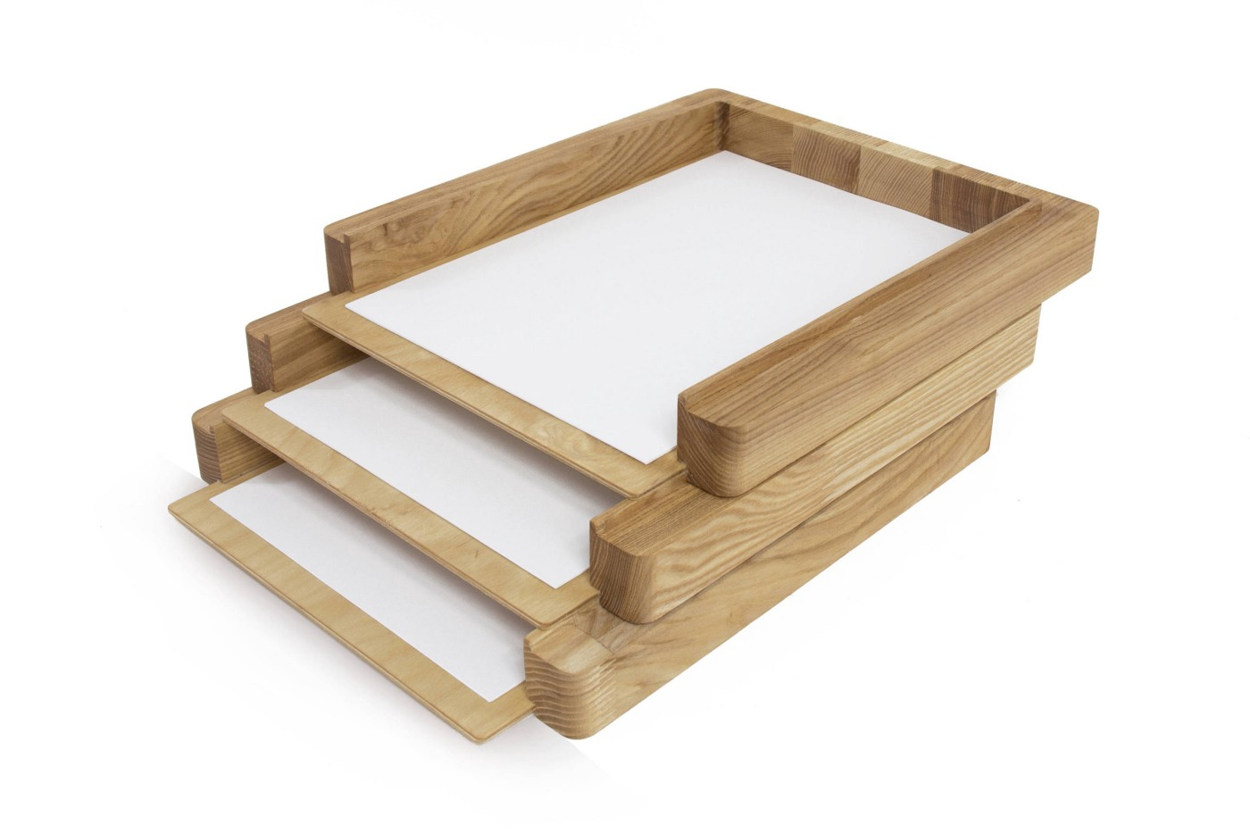

Wooden Paper Tray by [promidesign](http://promidesign.com/?attachment_id=3722" \t "_blank)

* Paper prototyping kits. Such kits include pre-made sheets (graph paper) and templates that make paper prototyping easier.

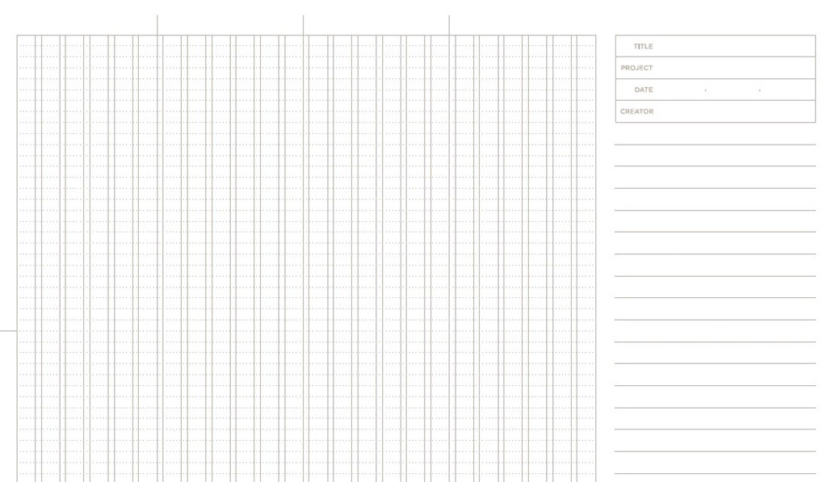

Graph paper. Image: [tripwiremagazine](http://www.tripwiremagazine.com/free-printable-sketching-wireframing-templates/" \t "_blank)

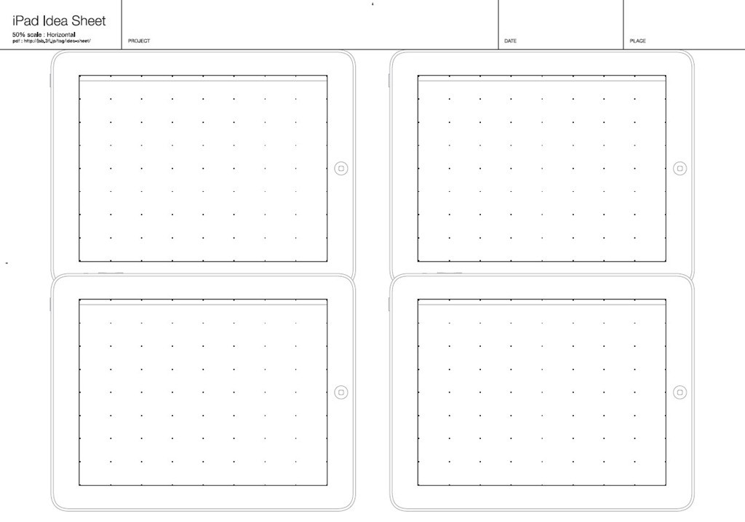

Templates for iPad. Image: [tripwiremagazine](http://www.tripwiremagazine.com/free-printable-sketching-wireframing-templates/" \t "_blank)

* Stencil. Stencils can help you quickly and accurately create buttons and icons.

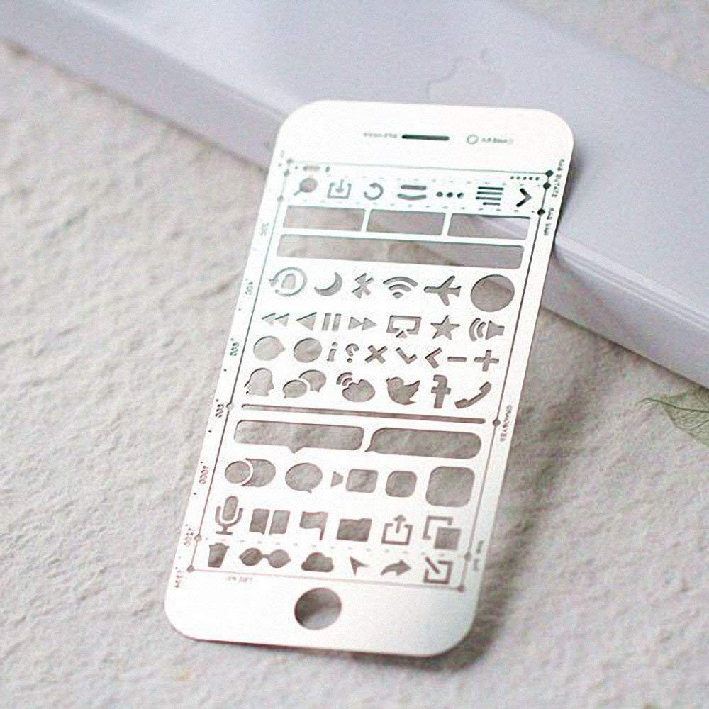

Stencil for iOS. Image: Amazon

**Important:** Good tools doesn’t mean expensive tools. In fact, it’s recommended using inexpensive pen and papers. Why? Because if you use Moleskin, you might subconsciously focus yourself on polishing your sketches (you don’t want to have ugly sketches in your Moleskin).

## 4. Use pen, not pencil

When it comes to sketching, many designers stumble on the common pitfall—they start sketching and somewhere in the middle of a process they start to question their ideas. As a result, they abandon some ideas without visualizing them first.

When you start sketching with a pen, it’s a better chance that you’ll finish the sketch. Why? Because pen creates a sense of commitment — it’s impossible to erase a sketch and start over.

## 5. Draw one sketch per screen

It might be tempting to save space and create a few states of a page/view on the same piece of paper. But it’s better to avoid that temptation. It will be much harder for people to test such prototypes — when you have too many things to show on the sketches, it becomes too cluttered, and test participants will have a hard time trying to understand which group of elements belong to one section.

## 6. Use colors intentionally

Draw up your prototype in black and white. Use colors intentionally — to highlight a specific element (such as buttons).

Also, as soon as you choose the colors you want to use, try to maintain consistency throughout the paper prototype. For example, all interactive elements should be colored in the same color (e.g. blue is used only for interactive elements). It will help you to reduce cognitive load during usability testing.

## 7. Create documentation out of the paper prototype

In the Agile environment, designers and developers always don’t have enough time to write proper documentation. Paper prototyping can be a problem solver. Since paper is a tangible document, designers can reuse them in a design process.

**Tip:** Take sketches that represent different screens or interactions and add notes. Notes will help you to convey the main idea to other people. Also, it’ll be much easier to recall specific design decisions after a while.

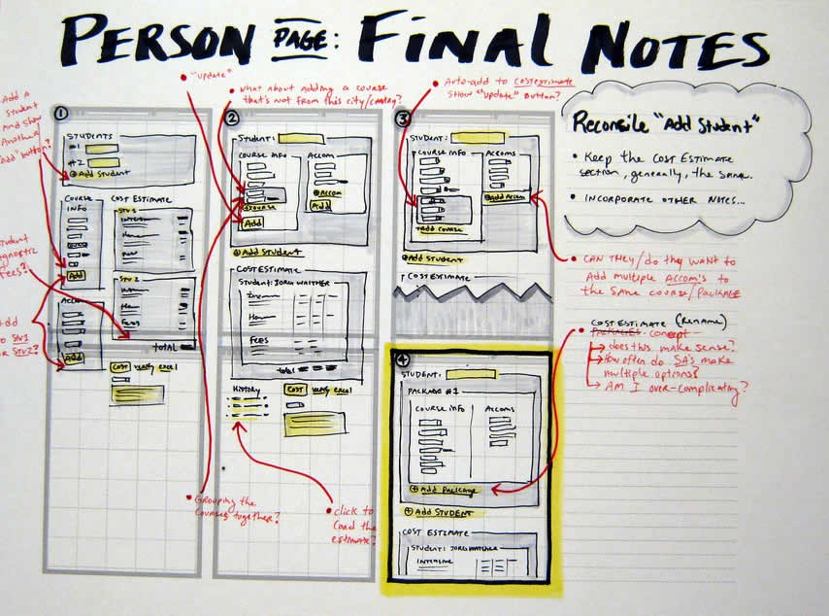

Image: [jasonrobb](http://jasonrobb.com/" \t "_blank)

## 8. Create a digital copy of your prototype

Create a digital copy of your prototype will help you to avoid carrying a pile of paper from meeting to meeting. All you need to do is to take a series of shots using your phone.

**Tip:** You can also create an animated GIF with a specific user flow. Simply take photos of sketches that represent a particular flow and create a GIF out of them.

## 9. Create a digital prototype out of a paper prototype

It’s also possible to use paper sketches as a basis for a low-fidelity digital prototype. There’s an excellent tool called [POP by Marvel](https://marvelapp.com/pop/) that can help you turn any sketch or image into an interactive prototype.

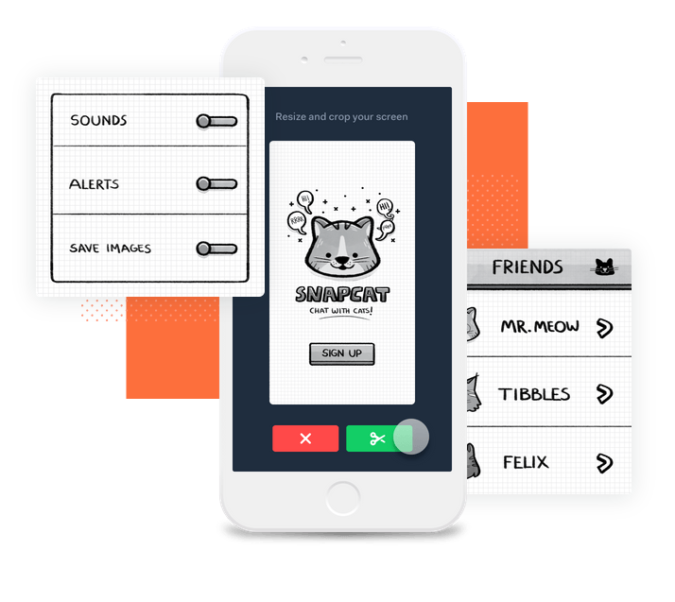

Image: Marvel

## 10. Create Complex Effects Using Paper

One of the great things about paper prototypes is the way designers come up with all kinds of creative ways of simulating visual effects or interactions. For example, with a little bit of imagination, it’s possible to create a scrolling effect on a mobile screen.



Simulate scrolling by pulling a long strip of content through the viewport. Image: [Csaba Házi](https://dribbble.com/hazicsaba)

It’s also possible to explore a different variety of elevations and shadows. Shadows will give your design a more realistic view, and it provides a much better perspective when you are validating your designs with users or clients.

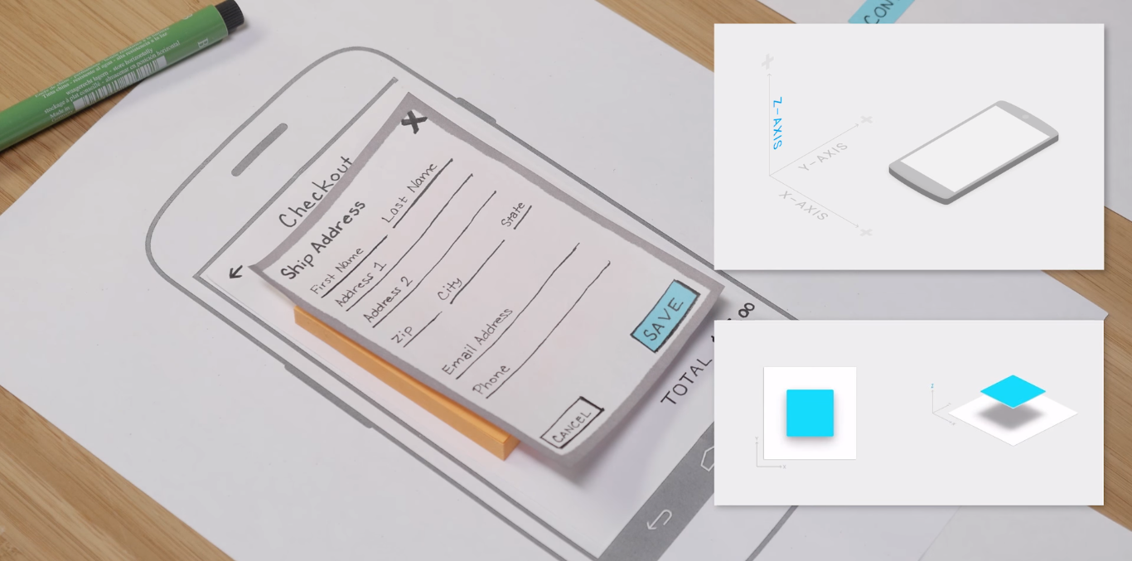

Image: [Google](https://www.youtube.com/watch?v=JMjozqJS44M)

# 3 Practical recommendations for Testing with paper prototypes

Why we build a prototype in a first place? The main reason for building prototypes is that we can test them on real users, get feedback and learn early whether our ideas and concepts work.

How to conduct testing with a paper prototype is a huge topic by itself that should be covered more extensively. Here I want to share a few basic things that should be taken into account when conducting testing with paper prototypes:

## 1. Facilitator and ‘Human-computer’ roles

If you plan to conduct testing sessions with a paper prototype, you’ll need two roles for each testing session:

* Facilitator (presenter). A person that instructs test participants and interacts with them.
* ‘Human computer.’ This person remains silent during the session and is in charge of changing screens or screen states, whenever the test participant interacts with a prototype. This role is extremely important — the effectiveness of testing often depends on how good the person playing the computer is at responding to a participant’s actions.

Avoid combining the roles of facilitator and ‘human computer.’ It’s a quite common problem when presenter who acts as a ‘human computer’ miss some vital information from test participants.



Image: [gfycat](https://gfycat.com/gifs/detail/GargantuanSoftHornet" \t "_blank)

## 2. Create Context for Testing

When showing someone a paper prototype to test participants, you need to be sure that they understand the context of the design. That’s why it so important to clearly explain the testing scenario and how the paper prototype works.

Here are a few fundamental questions that you need to answer before starting a session:

* Why did you create this prototype?
* What do you want to achieve with this testing session?
* What information do you want to receive from test participants?

## 3. Test with at Least 5 Different Users

Follow standard usability test best practices — test with at least [five different users](https://www.nngroup.com/articles/why-you-only-need-to-test-with-5-users/)and record the test sessions for further analysis.

# Conclusion

Paper prototyping is a great way to create and test new designs quickly. Correctly used, paper prototypes provide maximum learning for minimum effort.

**Do you have more tips for paper prototyping? Share your thoughts in comments!**

https://uxplanet.org/the-magic-of-paper-prototyping-51693eac6bc3